**Applied Operations Research Cafe/Restaurant Queue Problem**

Seçil YILDIRIM

181005056

**Cafe/Restaurant Problem**

We often encounter people waiting in line in our daily lives. Especially, for some restaurants in Paris, it may be necessary to make a reservation many months ago. The main reason for the formation of queues is that incoming customer requests for the service cannot be met instantly. Thus, a queue is a state of a waiting sequence (line) that is delayed due to a limited service.

My aim to minimize the waiting time in cafes by developing an application. Customers will be able to make a reservation before arriving at the cafe. They can book minutes in advance if they want, or weeks or months in advance if they want. The client must enter for the reservation which route he plans to come from, what category of food he intends to order, and how much time he would like to spend in the cafe. It can be predicted whether the customer will be late or not by looking at the future location and the current traffic. Taking into account the category of dishes the chooses. It can be analyzed service speed and how long it takes for customers who have previously come to the cafe and ordered from the same category to eat.

Customers who come to the cafe can get services at the same time. (limited to the number of cafe tables).

* (a / b / c ) : ( d / e / f )

**Formulas**

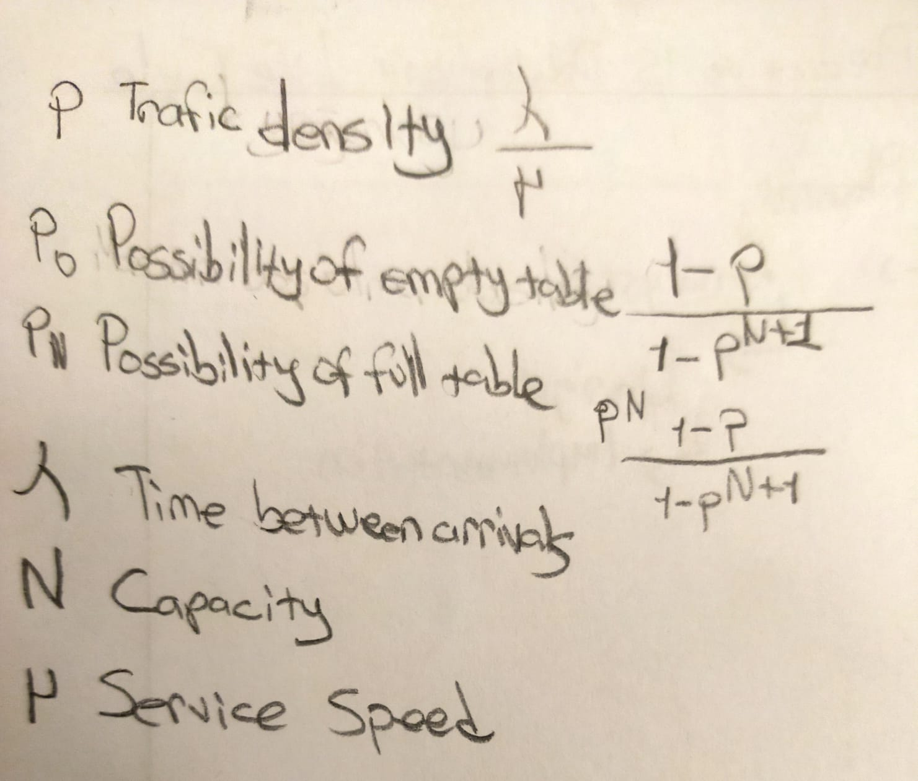

**Queue System**

